Melissa Yee

100729644 | February 3, 2020

AIDI 2004 – AI in Enterprise Systems

Lab #1 - Git

# Step 1

Install git in your local machine



# Step 2

## GitHub Account

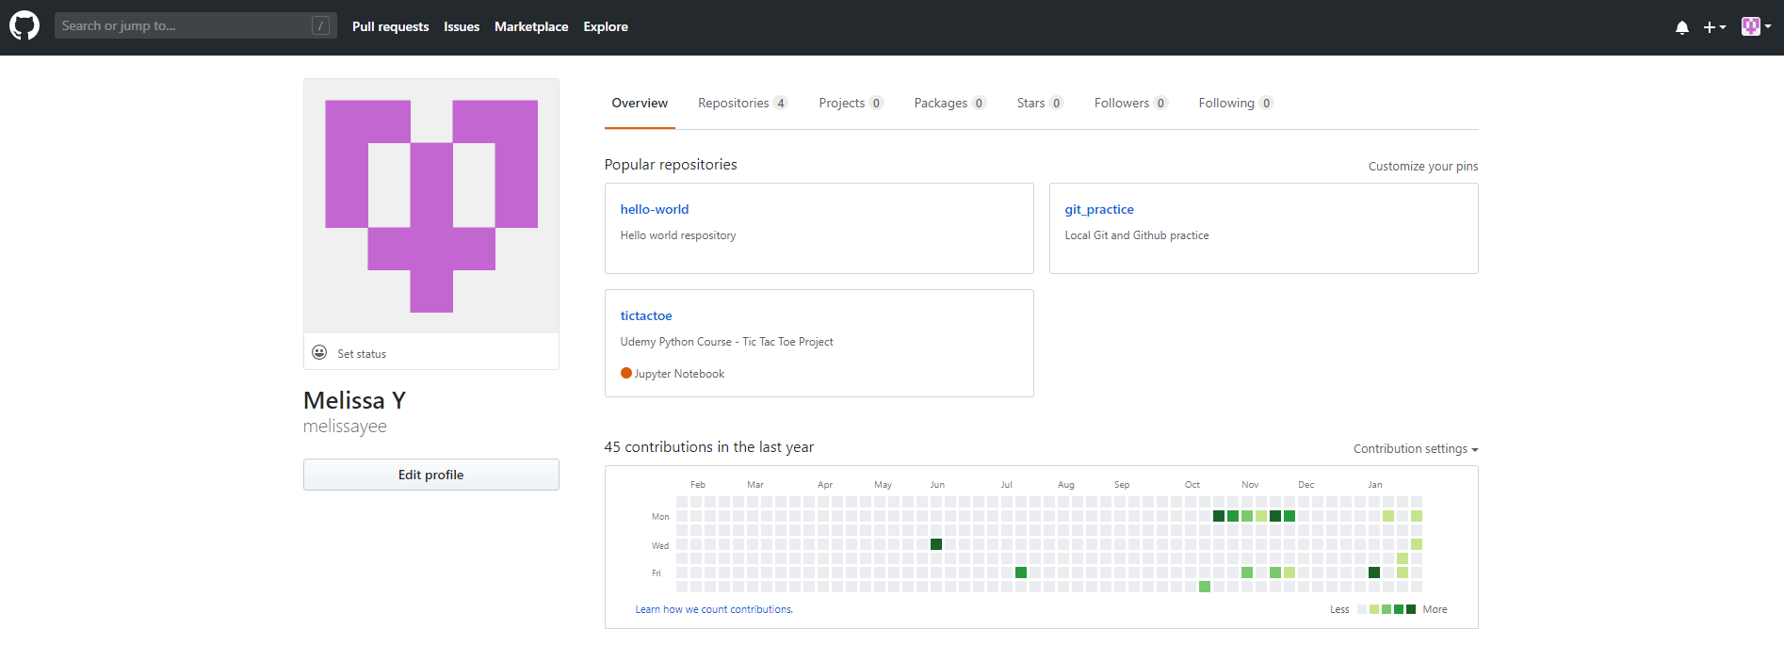

## GitLab Account

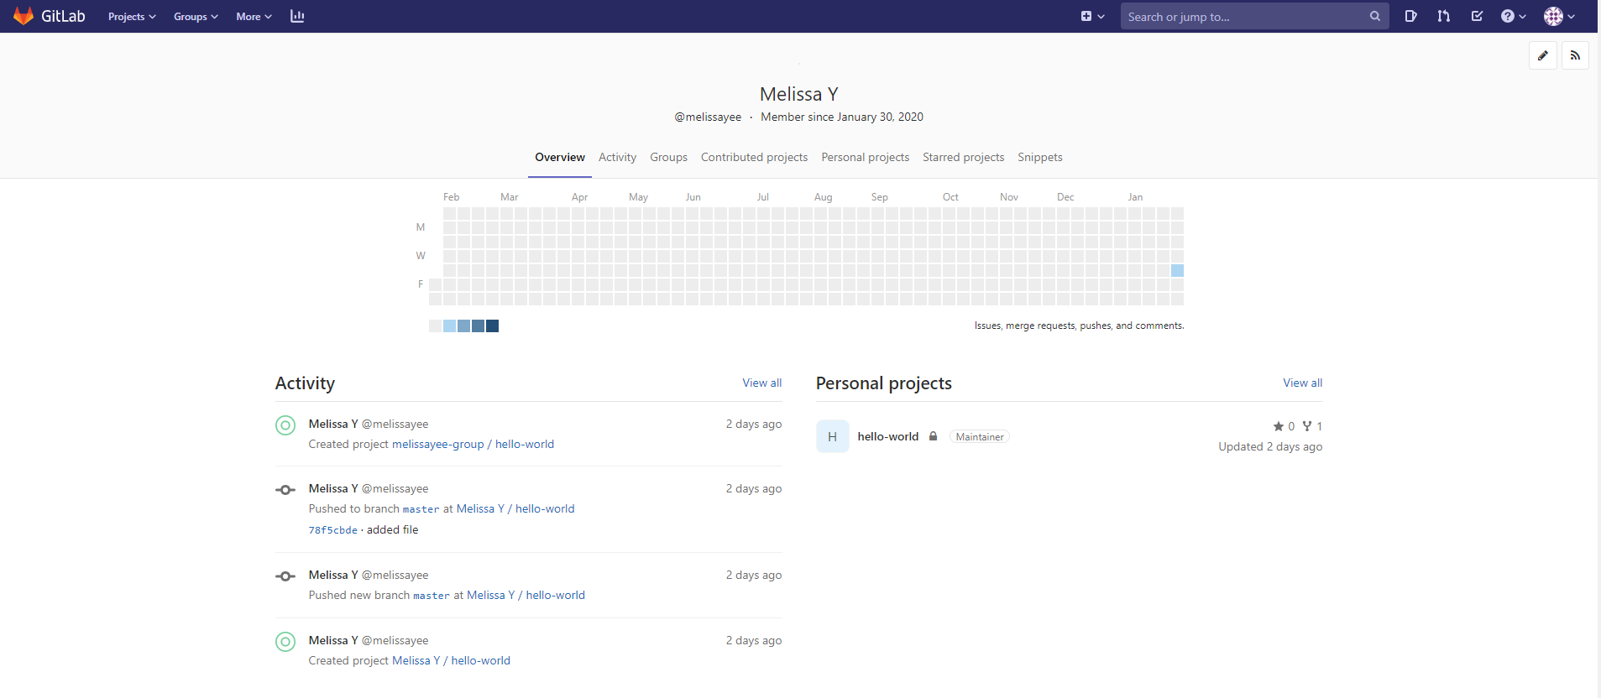

# Step 3

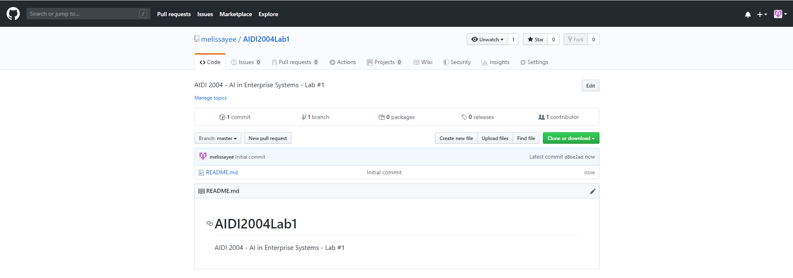

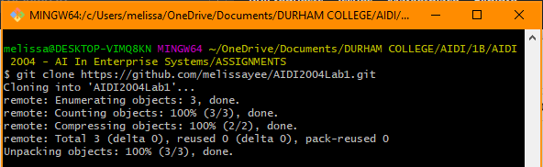

I’ve chosen GitHub as the location for my remote host because this is a personal project that won’t require the tools for Agile Development that GitLab provides. In addition, I’m much more familiar with using GitHub as opposed to GitLab, so using GitHub instead will make it easier for me to navigate and use.

# Step 4

Fibonacci Sequence program

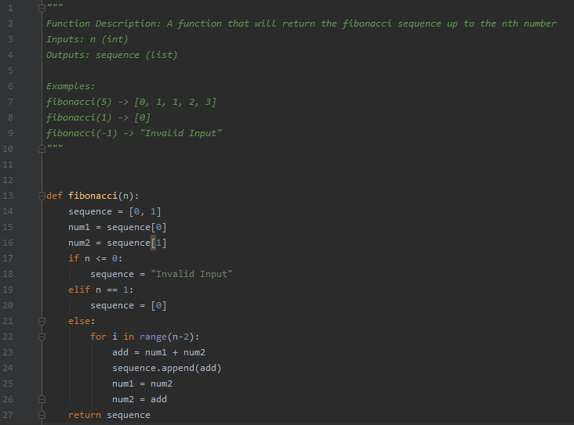

# Step 5

Successfully committed python file to master and pushed to origin

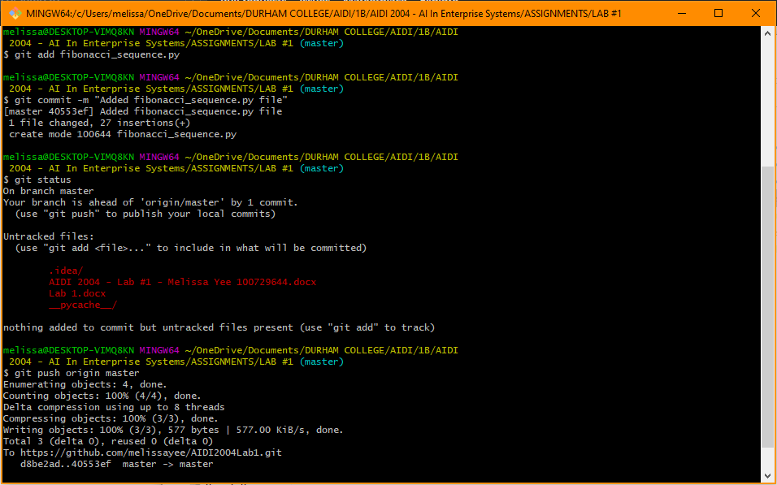

# Step 6

Updated README.md file with description of program

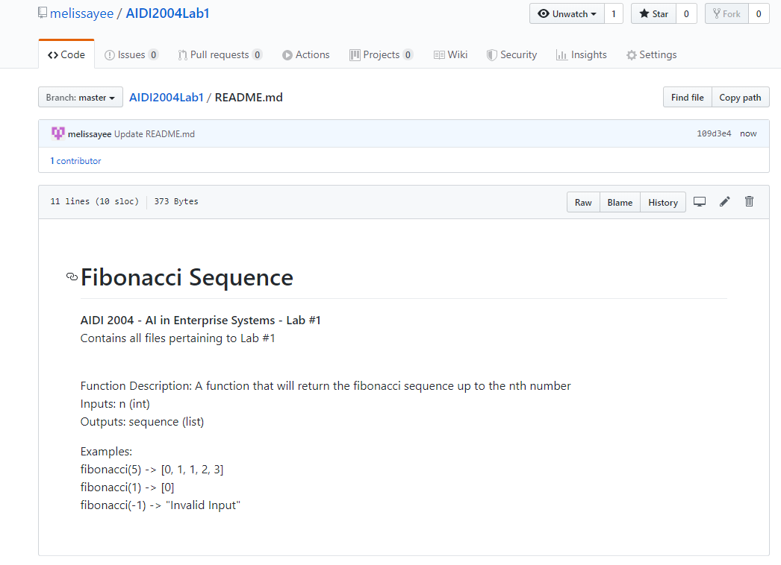

# Step 7

Added prime_finder.py file and other related lab files to branch new-files

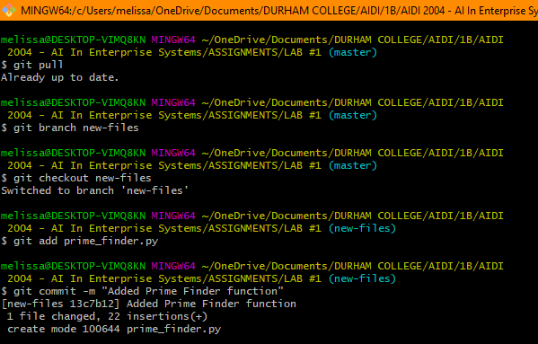

# Step 8

Status after adding all related lab files and committing to new branch

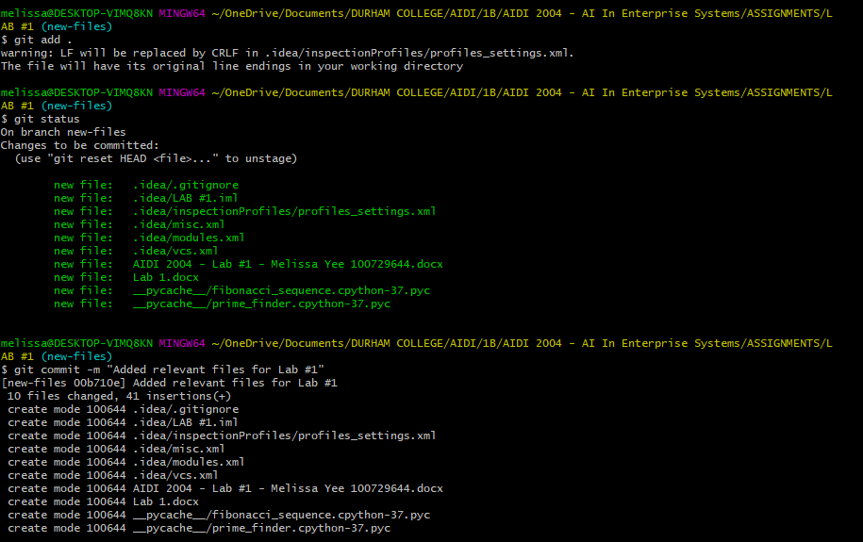

Committed and merged with master

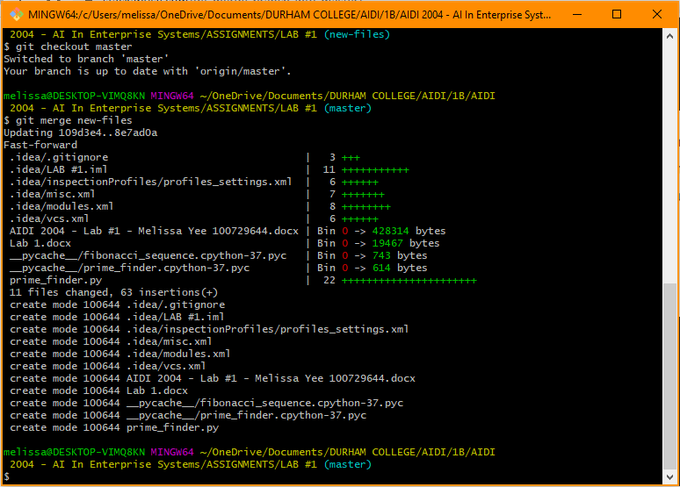

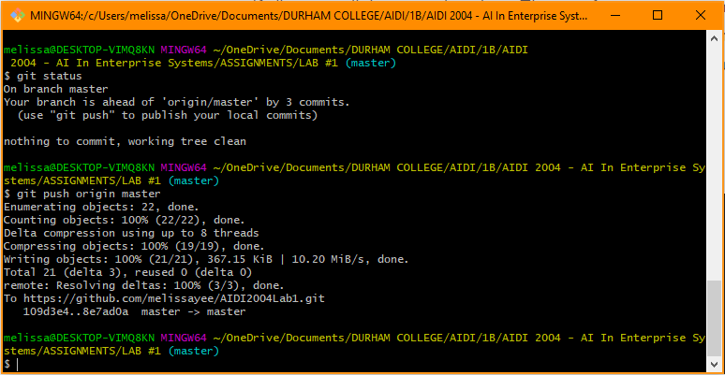

# Step 9

Git Commit Log

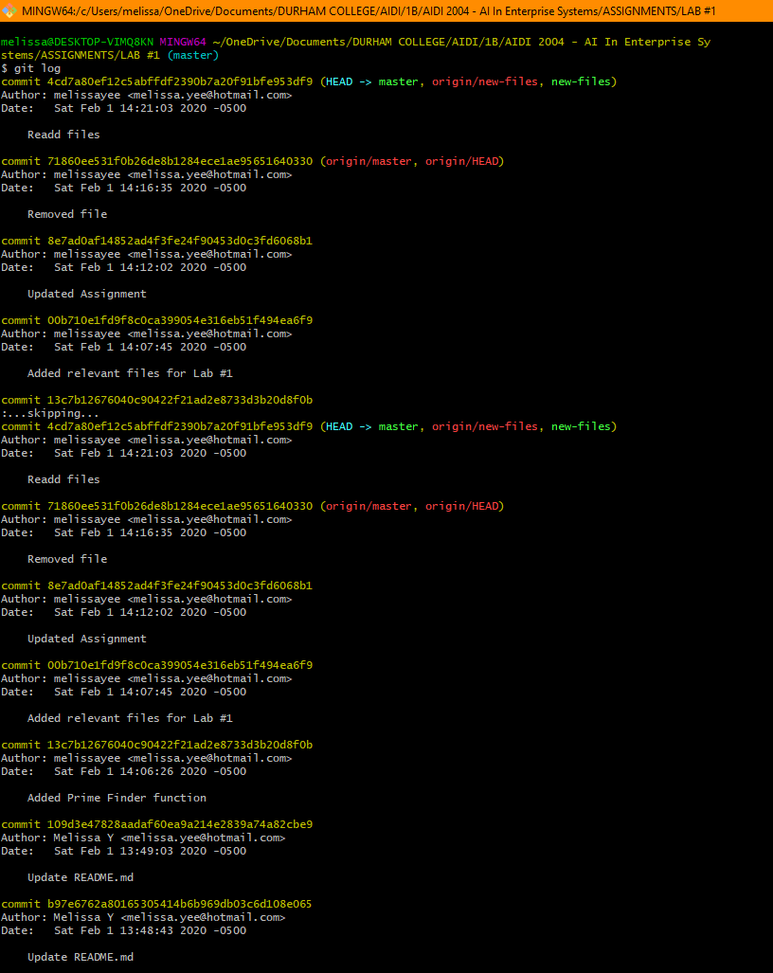

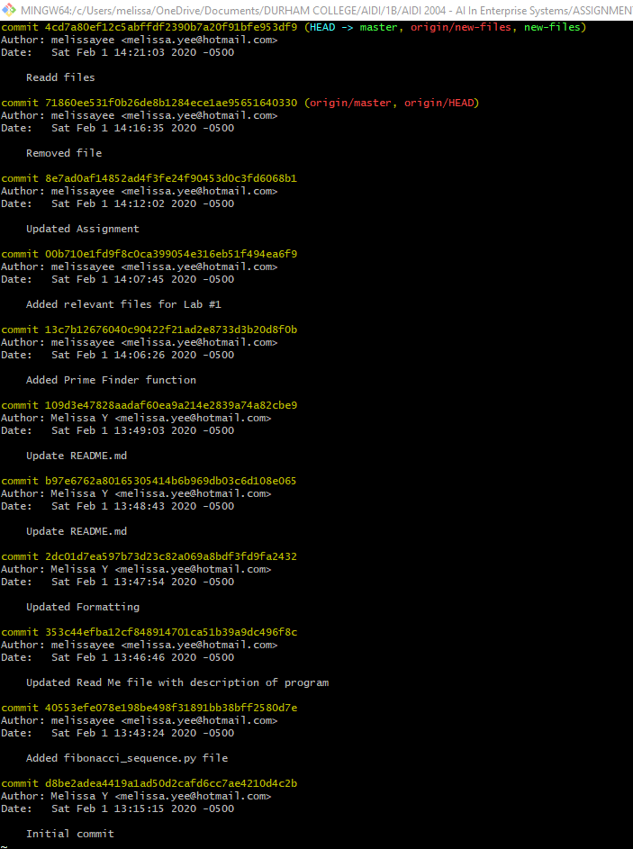

Final Commit

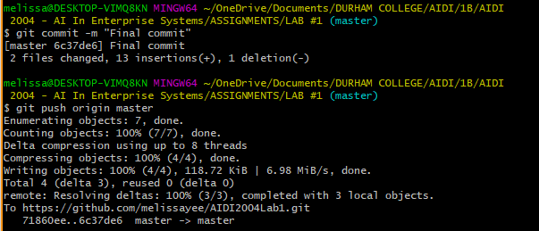

# Step 10

GitHub repository link: <https://github.com/melissayee/AIDI2004Lab1>